**ONLINE WEB PORTAL FOR NAVNATH ELECTRIC SHOP**

**“Web Portal for Navnath Electrical shop”**

In Partial Fulfillment of the Requirement for Award of the Degree of

**“BACHELOR OF BUSINESS ADMINISTRATOR (COMPUTER APPLICATION)”**

|  |  |  |
| --- | --- | --- |
|  | BY |  |
| **Gawand Prajwal Balaso** | **Roll No: -20** | **Exam Seat No: -** |
| **Kadam Tejas Shivaji** | **Roll No: -34** | **Exam Seat No: -** |



**Project Guide: - Mr. Anil Kaloke Sir VIDYA PRATISHTHAN’S**

**ART’S, SCIENCE AND COMMERCE COLLEGE, VIDYANAGARI, BARAMATI-43133**

**SAVITRIBAI PHULE PUNE UNIVERSITY,PUNE TYBBA(CA) (SEM V) YEAR (2024-2025)**

**VIDYA PRATISHTHAN’S**

**ARTS, SCIENCE AND COMMERCE COLLEGE, VIDYANAGARI, BARAMATI-413133**



CERTIFICATE

## DEPARTMENT OF COMPUTER APPLICATION

This is to certify that Mr. **Gawand Prajwal Balaso** & Mr.**Kadam Tejas Shivaji** TYBBA(CA) has

satisfactory at carried out the project work according to the syllabus prescribed by Savitribai Phule

Pune University,in COMPUTER APPLICATION and this project 2024-2025.

Roll No:- 20 Exam Seat No:-

Roll No:- 34 Exam Seat No:-

Batch In charge HOD

Date: / /2024 Date: / /2024

External Examiner Internal Examiner

Date: / /2024 Date: / /2024

**VIDYA PRATISHTHAN’S**

**ARTS, SCIENCE AND COMMERCE COLLEGE, VIDYANAGARI, BARAMATI-413133**



CERTIFICATE

## DEPARTMENT OF COMPUTER APPLICATION

This is to certify that Mr. **Gawand Prajwal Balaso** TYBBA(CA) has satisfactory at carried out the project work according to the syllabus prescribed by Savitribai Phule Pune University, in COMPUTER APPLICATION and this project 2024-2025.

Roll No:- 20 Exam Seat No:-

Batch In charge HOD

Date: / /2024 Date: / /2024

External Examiner Internal Examiner

Date: / /2024 Date: / /2024

**VIDYA PRATISHTHAN’S**

**ARTS, SCIENCE AND COMMERCE COLLEGE, VIDYANAGARI, BARAMATI-413133**



CERTIFICATE

## DEPARTMENT OF COMPUTER APPLICATION

This is to certify that Mr. **Kadam Tejas Shivaji** TYBBA(CA) has satisfactory at carried out the project work according to the syllabus prescribed by Savitribai Phule Pune University, in COMPUTER APPLICATION and this project 2024-2025.

Roll No:- 34 Exam Seat No:-

Batch In charge HOD

Date: / /2024 Date: / /2024

External Examiner Internal Examiner

Date: / /2024 Date: / /2024

INDEX

|  |  |  |
| --- | --- | --- |
| Sr no | Topic | Page no |
| **1** | Introduction | 8 |
| 1.1 | Abstract | 9 |
| 1.2 | Introduction | 9 |
| 1.3 | Existing system | 10 |
| 1.4 | Proposed system | 11 |
| 1.5 | Scope of system | 12 |
| 1.6 | Operating system | 13 |
| **2** | Analysis and Design | 14 |
| 2.1 | Fact Finding Techniques | 15 |
| **3** | Diagram | 19 |
| 3.1 | E-R Diagram | 21 |
| 3.2 | Class Diagram | 22 |
| 3.3 | Object Diagram | 23 |
| 3.4 | Use case Diagram | 24 |
| 3.5 | Activity Diagram | 25 |
| 3.7 | Sequence Diagram | 27 |
| 3.8 | Component Diagram | 28 |
| 3.9 | Deployment | 29 |

|  |  |  |
| --- | --- | --- |
| **4** | Tables | 30 |
| 4.1 | Tables and Data Dictionary | 31 |
| **5** | Input-Output Screen’s | 38 |
| **6** | Report’s | 49 |
| **6** | Conclusion | 52 |
| **8** | Advantages | 54 |
| **9** | Future Enhancements | 56 |
| **10** | Bibliography | 58 |

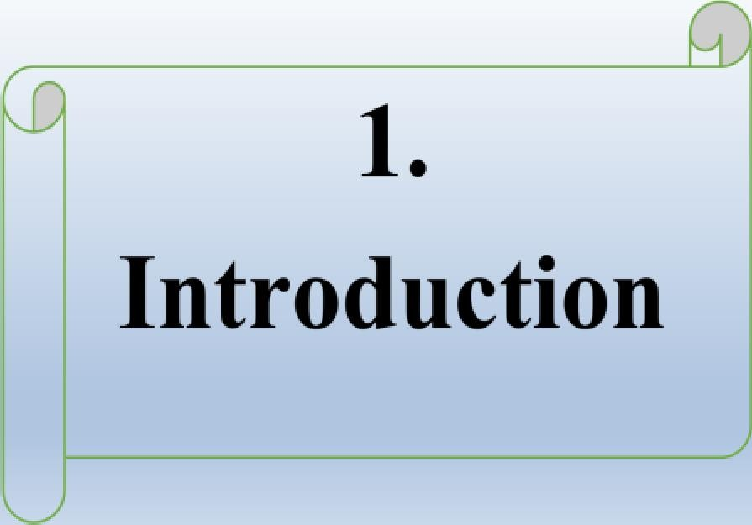

# 1.1 ABSTRACT

# The Online Web Portal for Navnath Electric Shop is a comprehensive digital platform designed to enhance the shopping experience for customers seeking electrical products and services. This portal provides a user-friendly interface, allowing customers to easily browse, search, and purchase a wide

# range of electrical items, including wiring, lighting fixtures, and appliances

# 1.2Introduction

The “Electrical Shop Management System” has a web based website. This software is supported to eliminate and in some cases reduce the hardships faced by this existing system. Electrical Shop Management software helps Electrical showrooms owners and management staff by producing different kind of financial and stock tracking reports, etc. This software is able to manage all electrical stocks. In this software shop owner can manage the data of customer and buyers.

# 1.3 Existing System

In the existing system the are done only manually but in proposed system we have To computerize the using this application.

Limitation Of Existing System:

* + Lack of security of data.
  + More man power.
  + Time consuming.
  + Cash-back offers not present.
  + Needs manual calculations.

# 1.4 Proposed System

The aim of proposed system is to develop a system of improved facilities. The system can overcome all the limitations of the existing system. The system provides proper security and reduces the manual work.

* + - Security of data.
    - Minimize manual data entry.
    - Minimum time needed for the various processing.
    - User friendliness and interactive.
    - Minimum time required.

# 1.5 Scope of the System

* + - To provide users to purchase electrical equipment online.
    - To reduce user’s searching time.
    - The satisfy the user requirements.
    - Be easy to operate.
    - Delivery on schedule within the budget.

# 1.6 Operating Requirement

## Hardware Requirement:-

* + - Processor : intel core i3
    - RAM : 8GB
    - Hard Disk : 512GB

## Software Requirement:-

* Operating System : Windows10
* Front End : Html5, Css3, JavaScript,
* Back End : PHP, MYSQL



2.

Analysis

# Fact Finding Techniques

Information gathering in large and Complex Organization is not an easy task. It has to be gathered in an organized way so that no system details left out, right problem ate identified, respective work is avoided and wrong details are not collected. The specific methods used for collecting data about requirements are called as fact-finding techniques.

They are: -

## Interview: -

This technique is used to collect information from individuals or groups. We need this technique frequently in the system analysis. We choose some administrator in college or school who take details of students and teachers and store it. Interview are not always source for collecting the information because of time required for interview.

Two Types of Interviews: -

## Structured Interview: -

Structured interview uses standardized questions. In structure interview time may be limited. It required deep study and preparation.

## Unstructured Interview: -

It allows respondent to answer in their own words. In this interview different types of the questions are raised. It may collect extra and unnecessary information.

Following are some questions:

1. How does you find the data?
2. How do you keep information about transections?
3. Where is entry made?
4. What are the major and minor problems in the existing system?
5. Which method are used to solve the problems?

## Observation: -

Observation method is most useful when the analyst needs to be actually observed how documents are handle, how process is carried out and whether specified steps are actually followed or not. It provides close view of the working of the real system. System analyst observes people, objects, documents and occurrences of events. It allows analyst to get information, which they cannot obtained from the other fact-finding techniques.

# Feasibility of System

Feasibility System carried out whether there are complex problems. A feasibility study is under taken to determine the possibility or the probability of the either improving the existing problems or developing a completely new system.

Following are the types of feasibility: -

## Technical feasibility

* + 1. **Economical feasibility**

## Operational feasibility

* + 1. **Technical feasibility: -**

Technical feasibility determines whether it is possible to develop the project with available equipment, available software technology and the manpower. If there is any kind of need in order to develop software in this case the cost of hardware, software and technical are considered. The software is used Intel Core i3, RAM 8GB, 500GB SSD, any printer, operating system windows 7, windows 10, windows 11 & XAMMP. That’s why our system is technically feasible.

## Economical feasibility: -

In this the benefit of the system are considered. Actually, the cost must include both one time cost and recurring cost. One time cost includes feasibility study cost, and cost for converting from present system in new system, cost of software package. Recurring cost may include rental or purchase of equipment, salaries of personal supplies, maintenance. That’s why our system is economical feasible.

## Operational feasibility: -

After implementing the system, the training program are arranged for the users. This is carried out by the people who are familiar with information system as well as the techniques. They are experienced person like managers, system analyst. Functioning of the system is very predictable smooth because of error handling, Graphical User Interface (GUI), Consistent User Interface (CUI). That’s Why our system is operational feasible



3

Diagram

# E-R Diagram

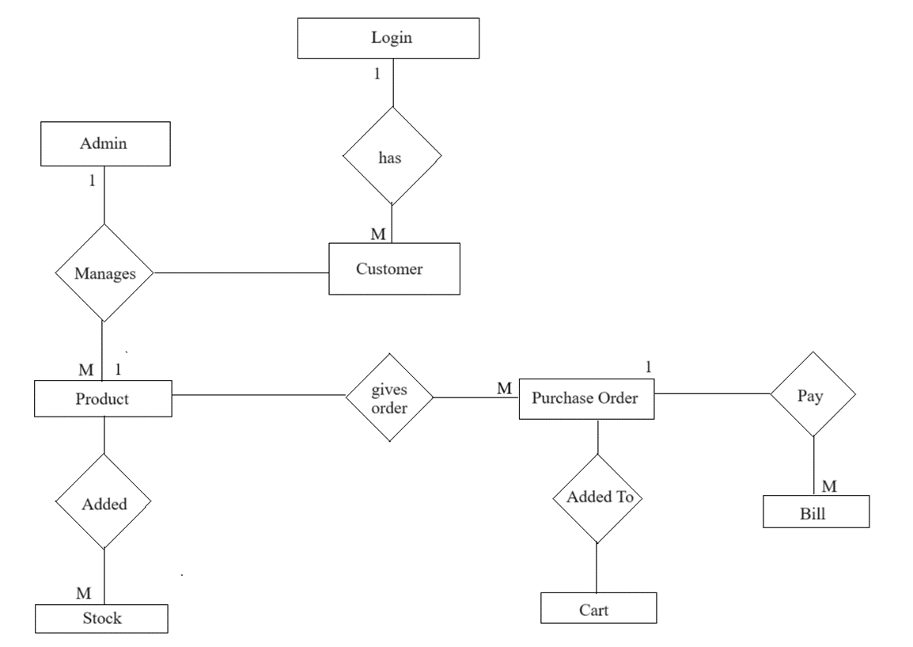

**3.2 Class Diagram-**

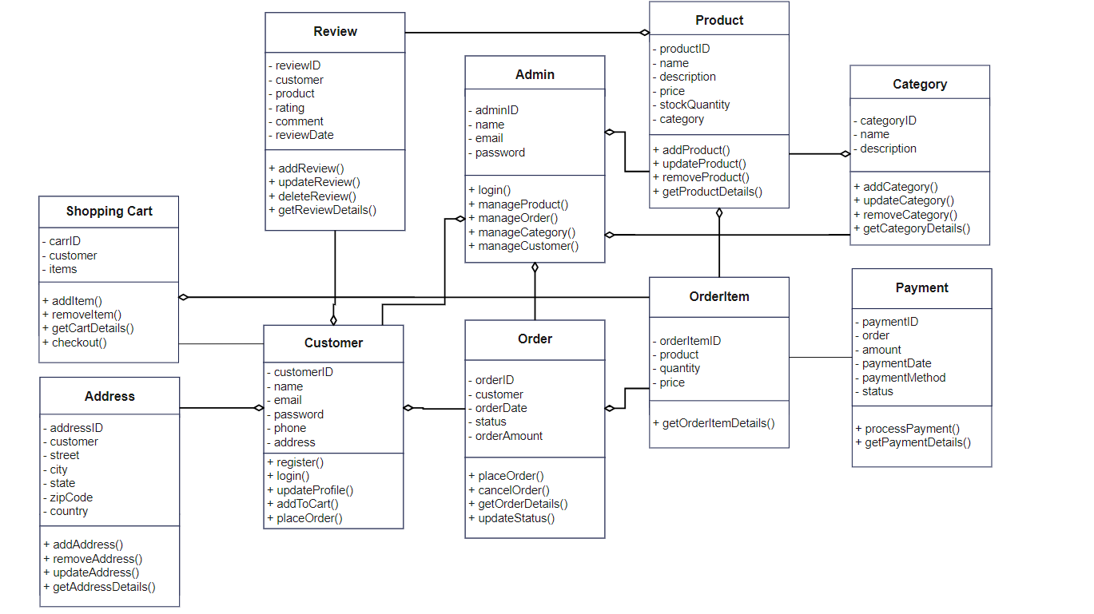

**3.3 Object Diagram-**

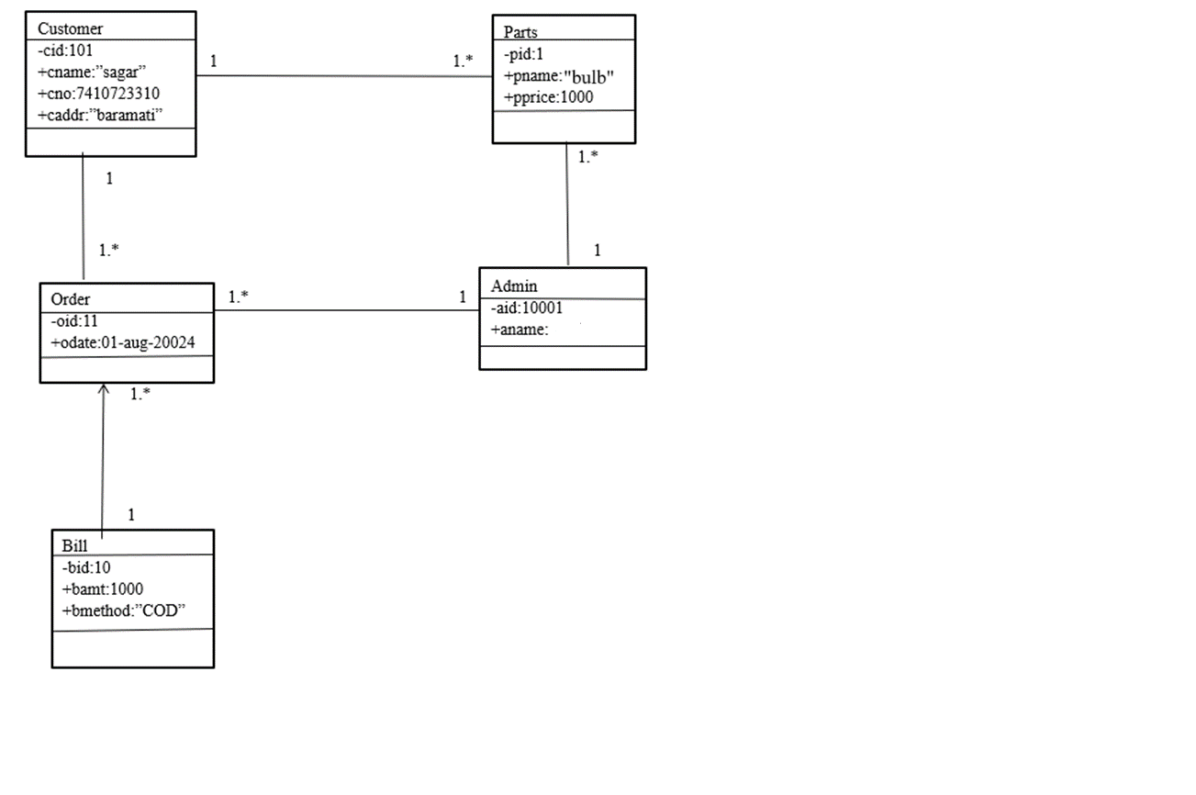

**3.4 Use case Diagram**

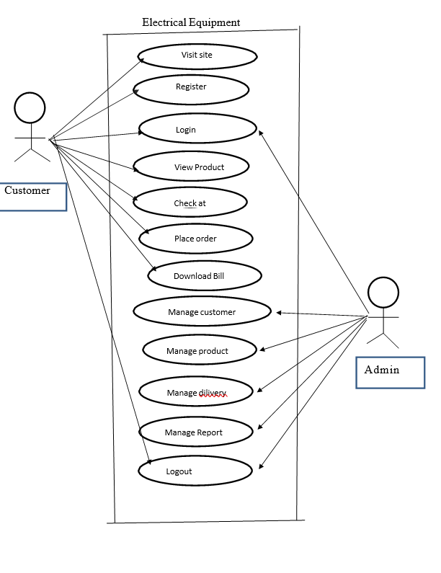

# 3.5 Activity Diagram

**Admin Side-**

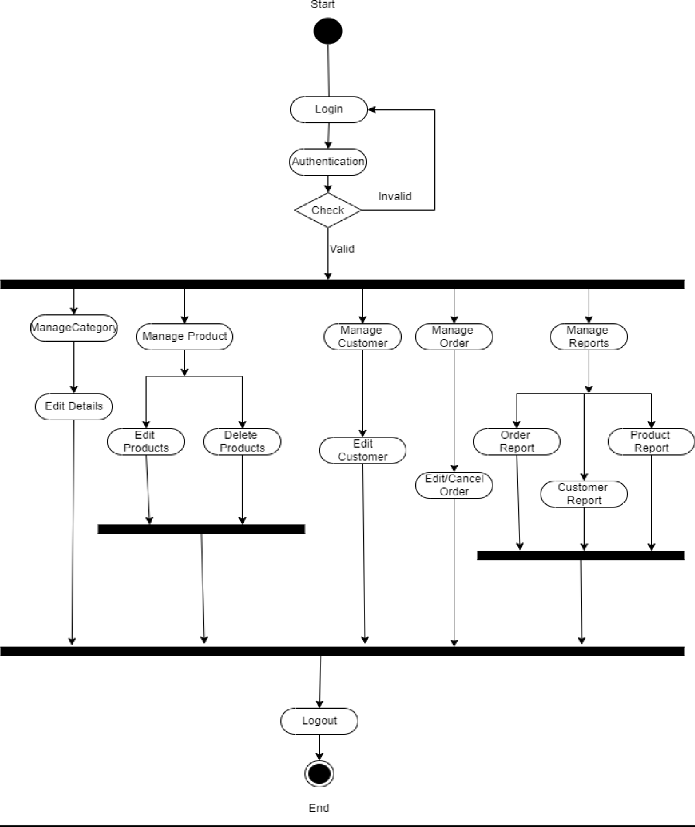

**3.6 Customer Side**

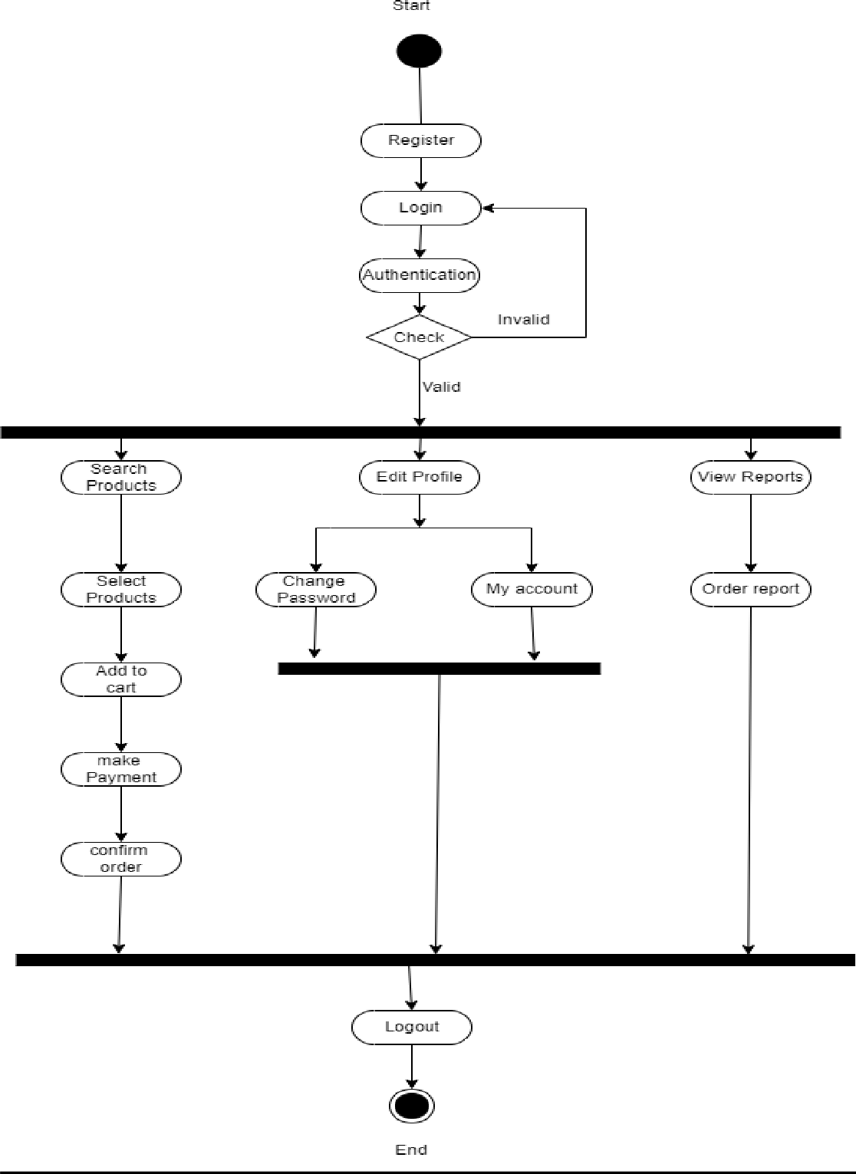

# 3.7 Sequence Diagram

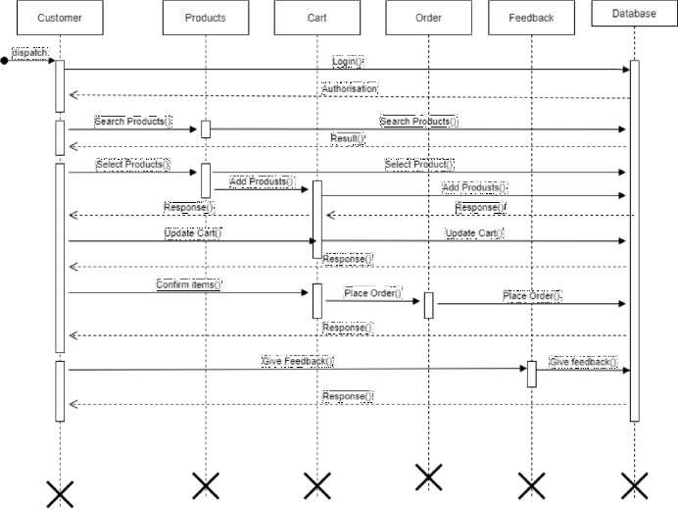

**3.7Component Diagram-**

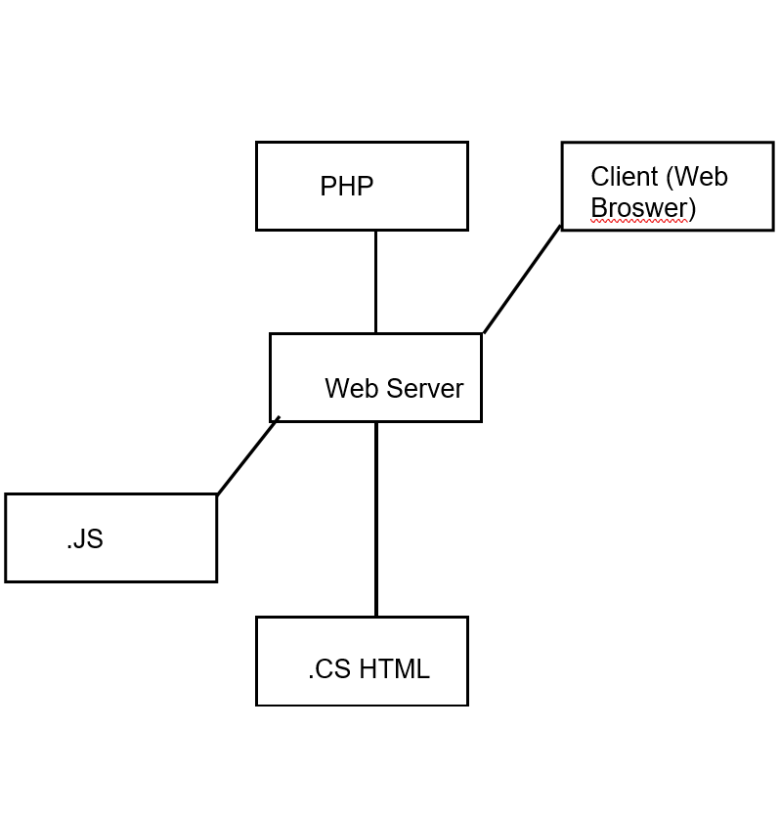

# 3.8 Deployment-

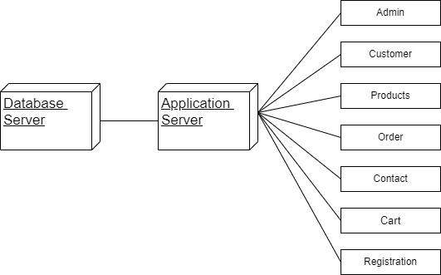



4.

Tables

## 4.1 Tables and Data Dictionary Admin Table: -

|  |  |  |  |  |  |
| --- | --- | --- | --- | --- | --- |
| **Data Elements** | **Description** | **Type** | **Length** | **A List of specific Value** | **Data store** |
| Aid | Admin id | number | 20 | It stores Admin id | Admin details |
| Username | Admin Username | text | 20 | It stores Admin Username | Admin details |
| Password | Admin Password | text | 20 | It stores Admin Password | Admin Details |

**Category Table: -**

|  |  |  |  |  |  |
| --- | --- | --- | --- | --- | --- |
| **Data Elements** | **Description** | **Type** | **Length** | **A List of specific Value** | **Data store** |
| Ctid | Category id | number | 20 | It stores Category id | Category details |
| Ctname | Category Name | text | 20 | It stores Category name | Category details |

## 

## Customer Table: -

|  |  |  |  |  |  |
| --- | --- | --- | --- | --- | --- |
| **Data Elements** | **Description** | **Type** | **Length** | **A List of specific Value** | **Data store** |
| cid | Customer id | number | 20 | It stores  Customer id | Customer  details |
| Fname | Customer First Name | text | 20 | It stores Customer first name | Customer details |
| Lname | Customer Last Name | text | 20 | It stores Customer Last name | Customer details |
| Password | Customer  Password | text | 20 | It stores Customer password | Customer  details |
| Mobno | Customer mobile number | number | 20 | It stores Customer mobile no | Customer details |
| Email | Customer email id | text | 20 | It stores Customer email id | Customer details |
| Address | Customer  address | text | 20 | It stores Customer address | Customer  details |

**Product Table: -**

|  |  |  |  |  |  |
| --- | --- | --- | --- | --- | --- |
| **Data Elements** | **Description** | **Type** | **Length** | **A List of specific Value** | **Data store** |
| Ctid | Category id | number | 20 | It stores  Category id | Category  details |
| Pid | Product id | Number | 20 | It stores Product id | Product details |
| Pname | Product Name | text | 20 | It stores Product name | Product details |
| Pprice | Product price | text | 20 | It stores Product price | Product details |
| Pdescrip | Product Description | text | 20 | It stores Product Description | Product details |
| Ppics | Product Image | text | 20 | It stores Product Image | Product details |

**Order Table: -**

|  |  |  |  |  |  |
| --- | --- | --- | --- | --- | --- |
| **Data Elements** | **Description** | **Type** | **Length** | **A List of specific Value** | **Data store** |
| Oid | Order id | number | 20 | It stores Order  id | Order  details |
| Funame | Customer Full Name | text | 20 | It stores Customer first name | Customer details |
| Zip | Customer Last Name | text | 20 | It stores Customer Last name | Customer details |
| Paymod | Customer Password | text | 20 | It stores Customer password | Customer details |
| Mobno | Customer mobile number | number | 20 | It stores Customer mobile no | Customer details |
| Email | Customer email id | text | 20 | It stores Customer email id | Customer details |
| Address | Customer address | text | 20 | It stores Customer address | Customer details |
| City | Customer City | Text | 20 | It stores customer city | Customer details |
| Ptotal | Total amount of product | Int | 20 | It stores total items price | Product details |
| Status | Order status | text | 20 | It stores the order status | Order details |
| Odate | Order date | date | - | It stores order date | Order details |

## Feedback Table: -

|  |  |  |  |  |  |
| --- | --- | --- | --- | --- | --- |
| **Data Elements** | **Description** | **Type** | **Length** | **A List of specific Value** | **Data store** |
| Fid | feedback id | number | 20 | It stores feedback id | feedback details |
| Frname | Customer first name | text | 20 | It stores Customer first name | Contact details |
| Laname | Customer Last  name | text | 20 | It stores Customer Last name | Contact  details |
| Emailed | Customer Emailid | text | 20 | It stores Customer email id | Contact details |
| Massage | massage | text | 20 | It stores Customer massage | Contact details |

**Cart Table: -**

|  |  |  |  |  |  |
| --- | --- | --- | --- | --- | --- |
| **Data Elements** | **Description** | **Type** | **Length** | **A List of specific Value** | **Data store** |
| orderid | order id | number | 20 | It stores order  id | User_order  details |
| Productname | Product name | text | 20 | It stores user order products name | Order products details |
| Price | Product price | number | 20 | It stores user order products name | Order products details |
| Quantity | Product quantity | number | 20 | It stores user order products name | Order products details |



5

Input O. utput Screen

## Fig.Homepage

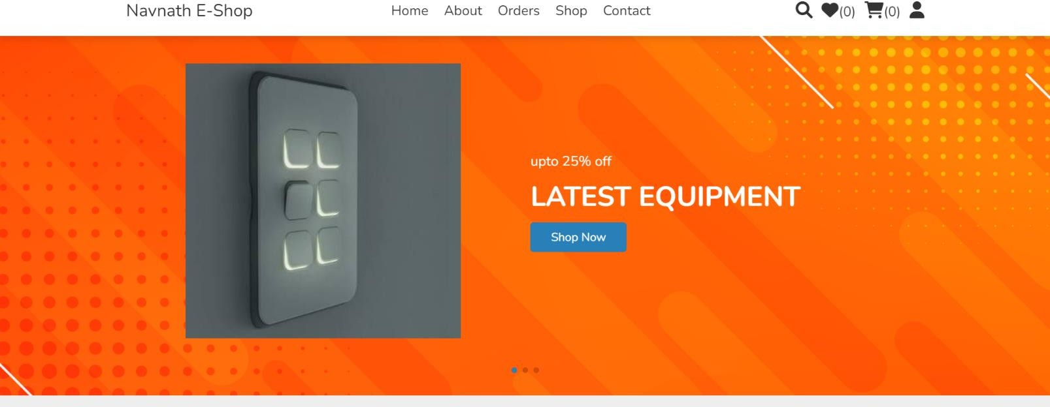

**Fig.About Us**

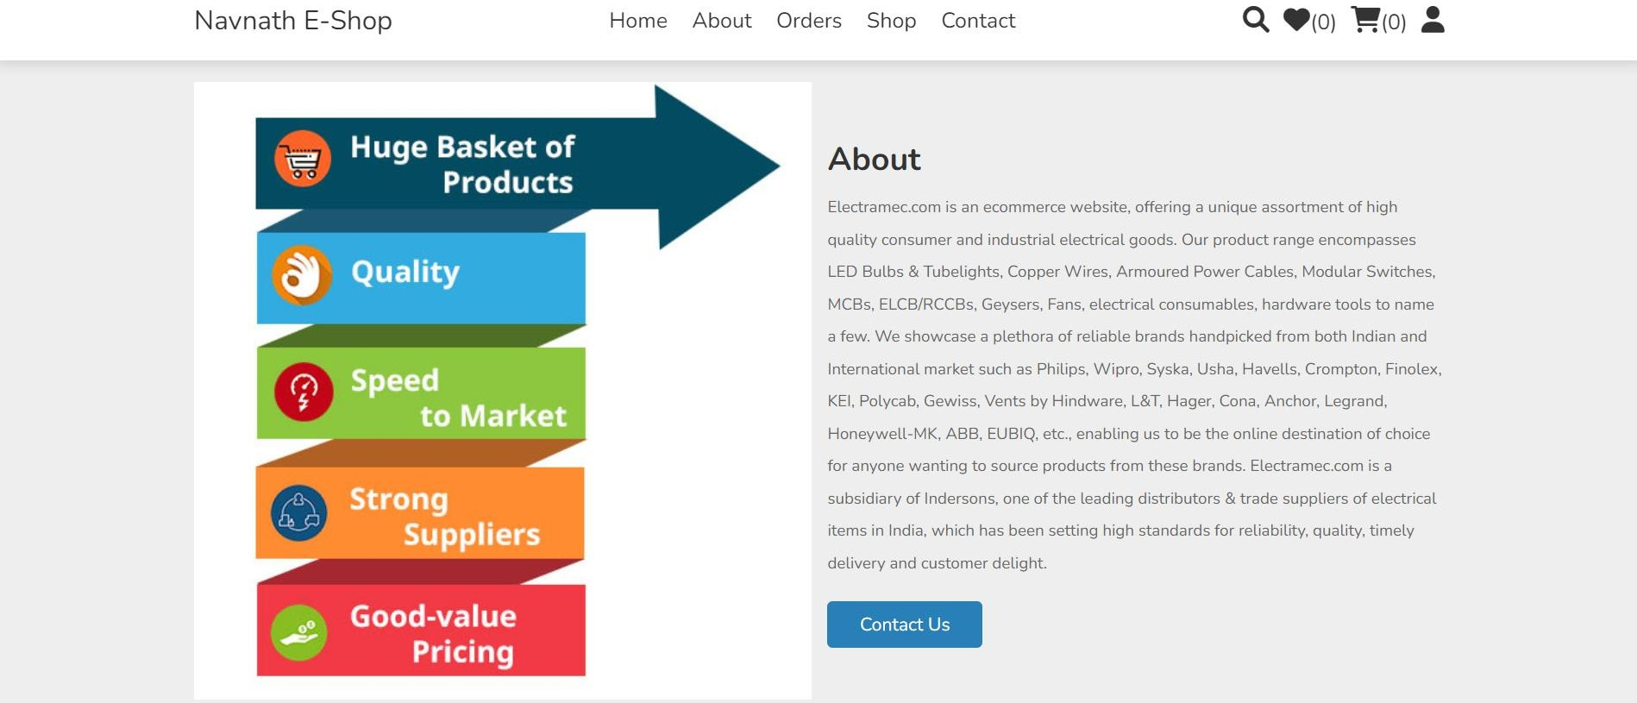

## Fig. Customer Registration

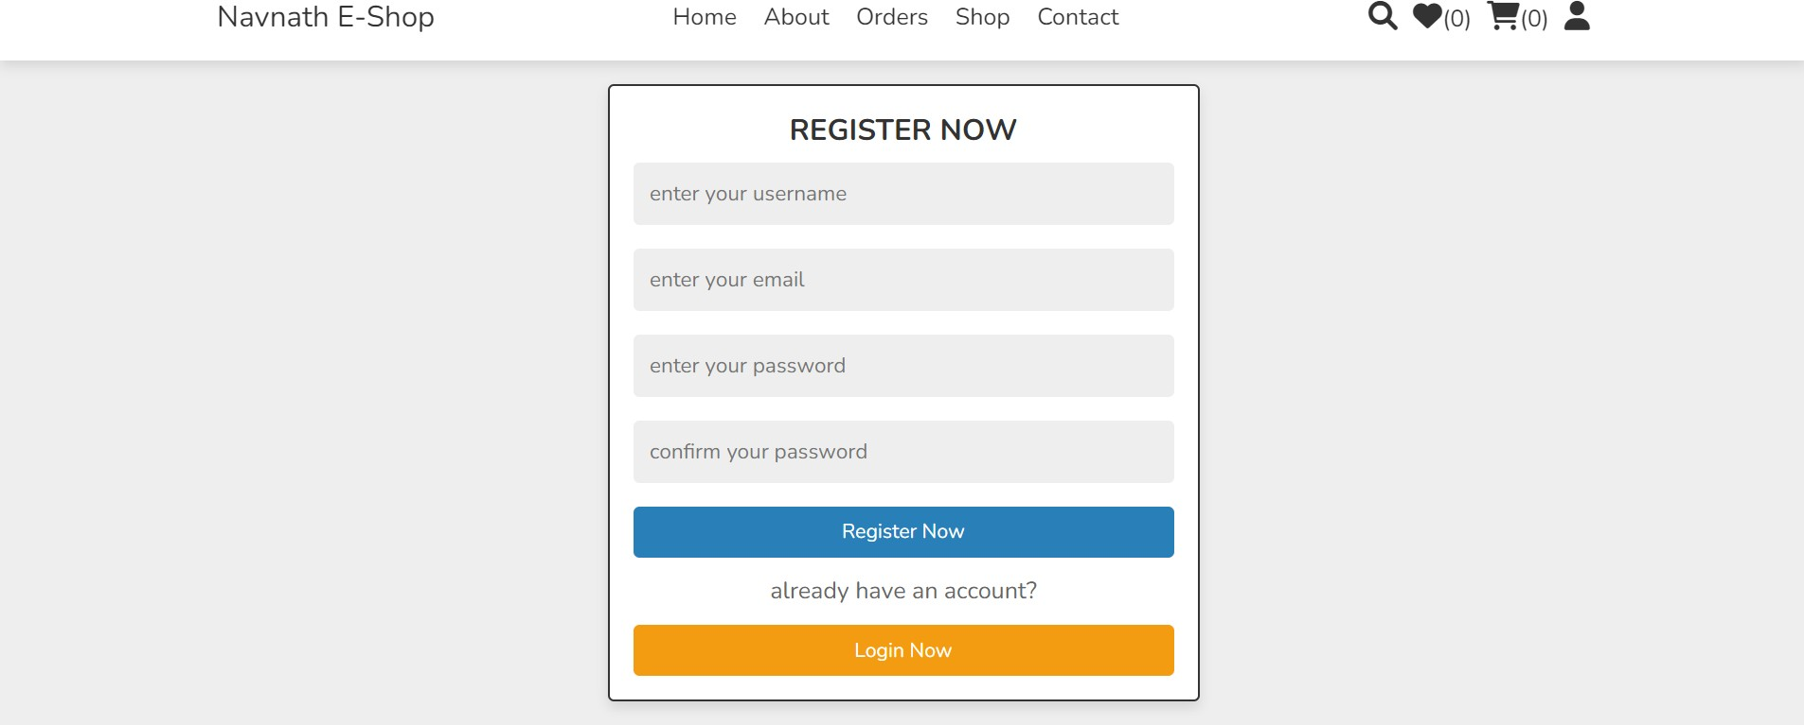

**Fig. Customer Login**

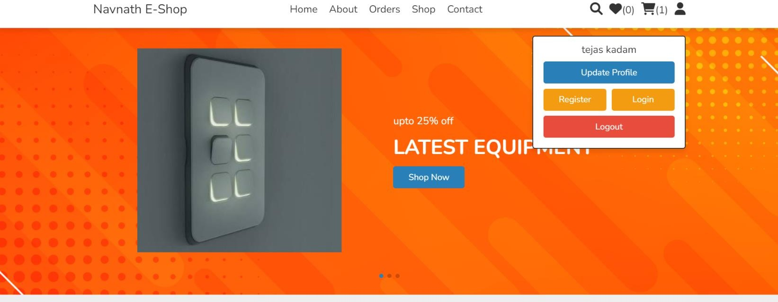

## Fig. Products

## 

**Fig. Admin login**

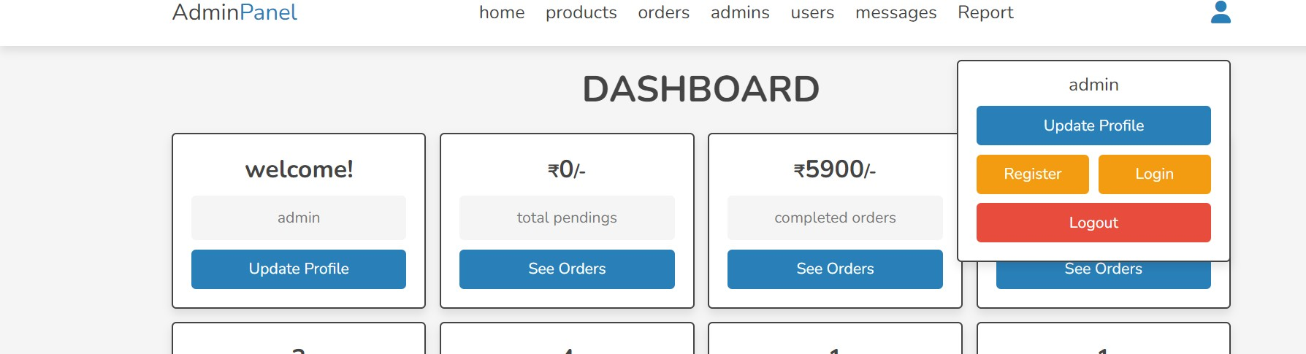

# Fig. Admin dashboard

# 

## Fig. Contact Us

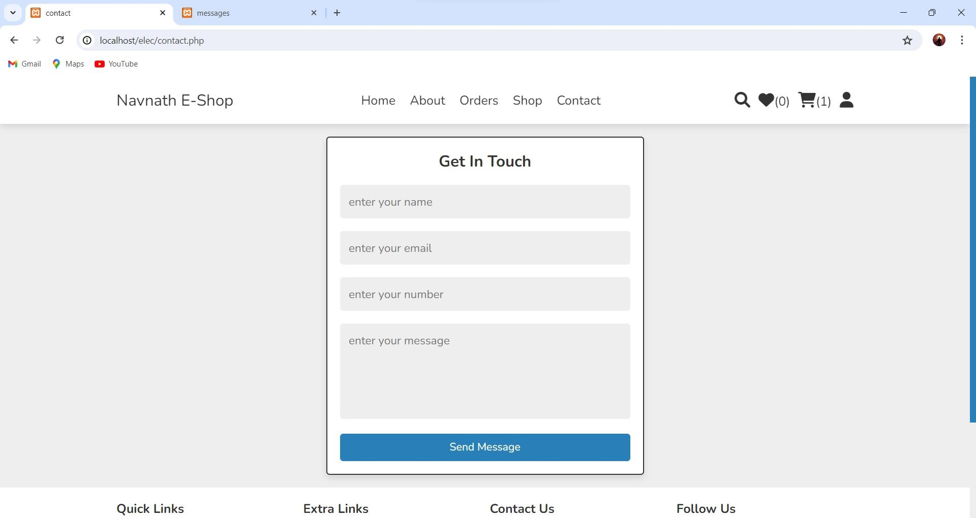

**Fig. customer order**

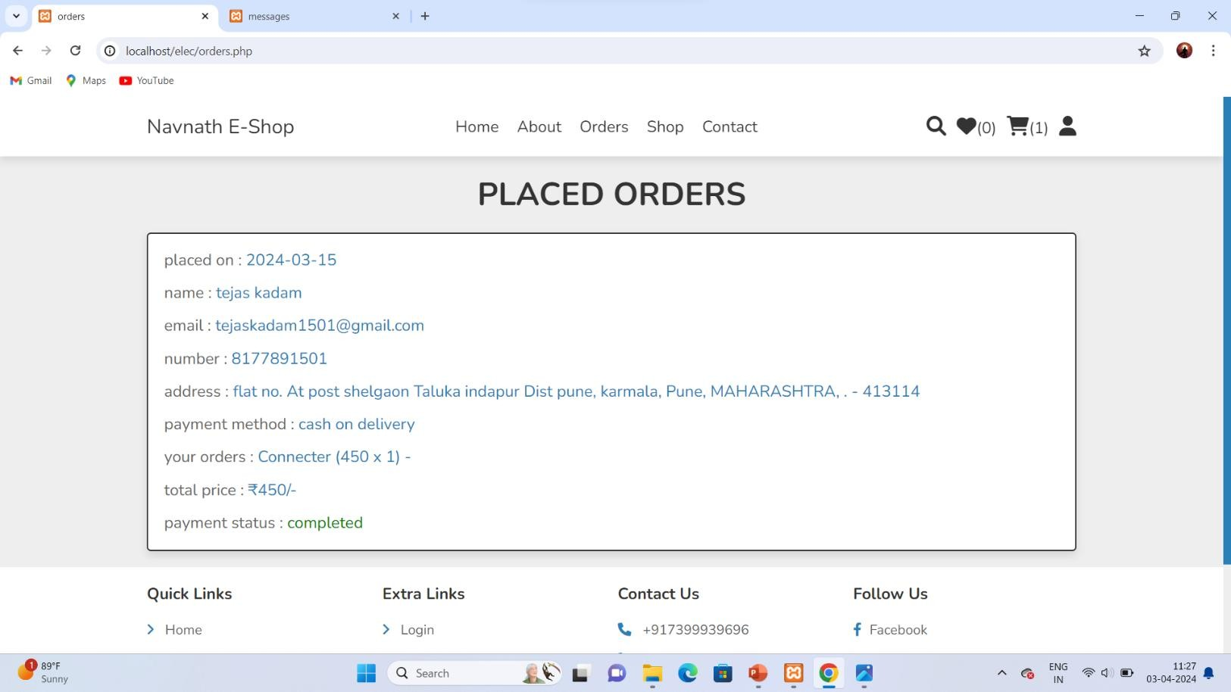

## Fig.Feedback

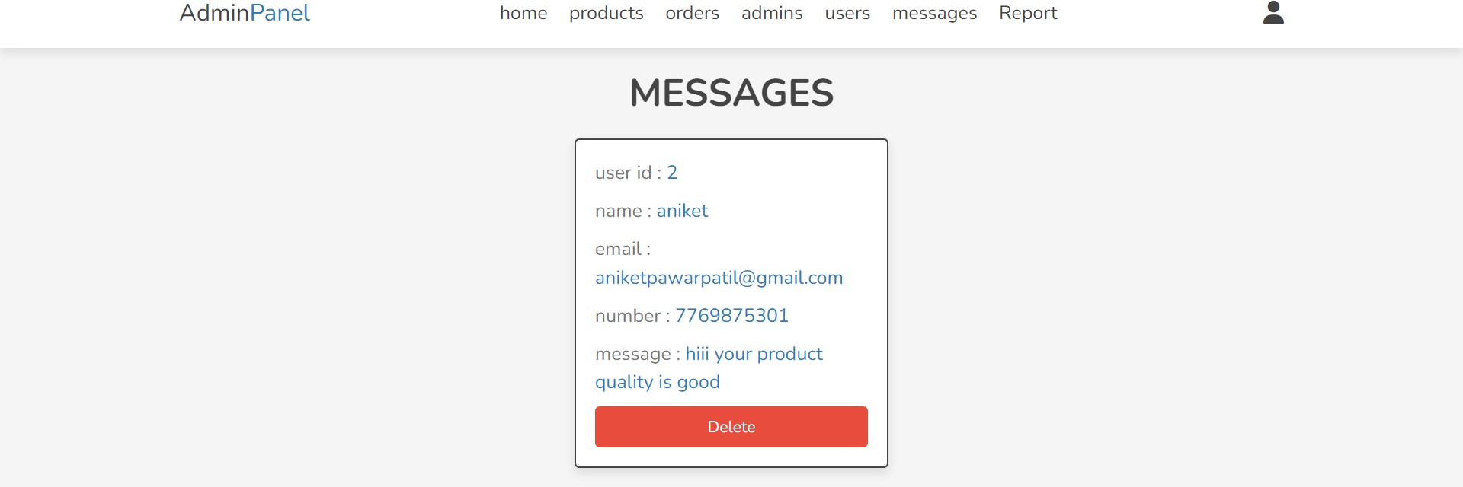



6.

Report

**Customer Report**

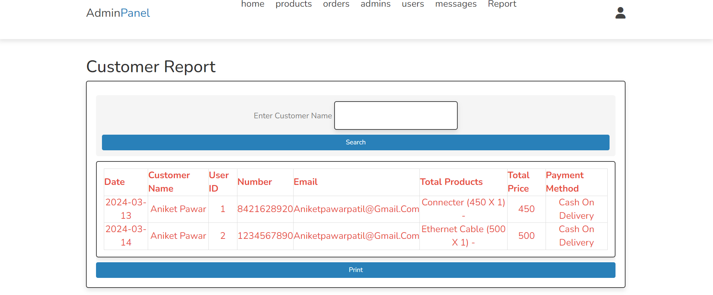

**Sale Report**

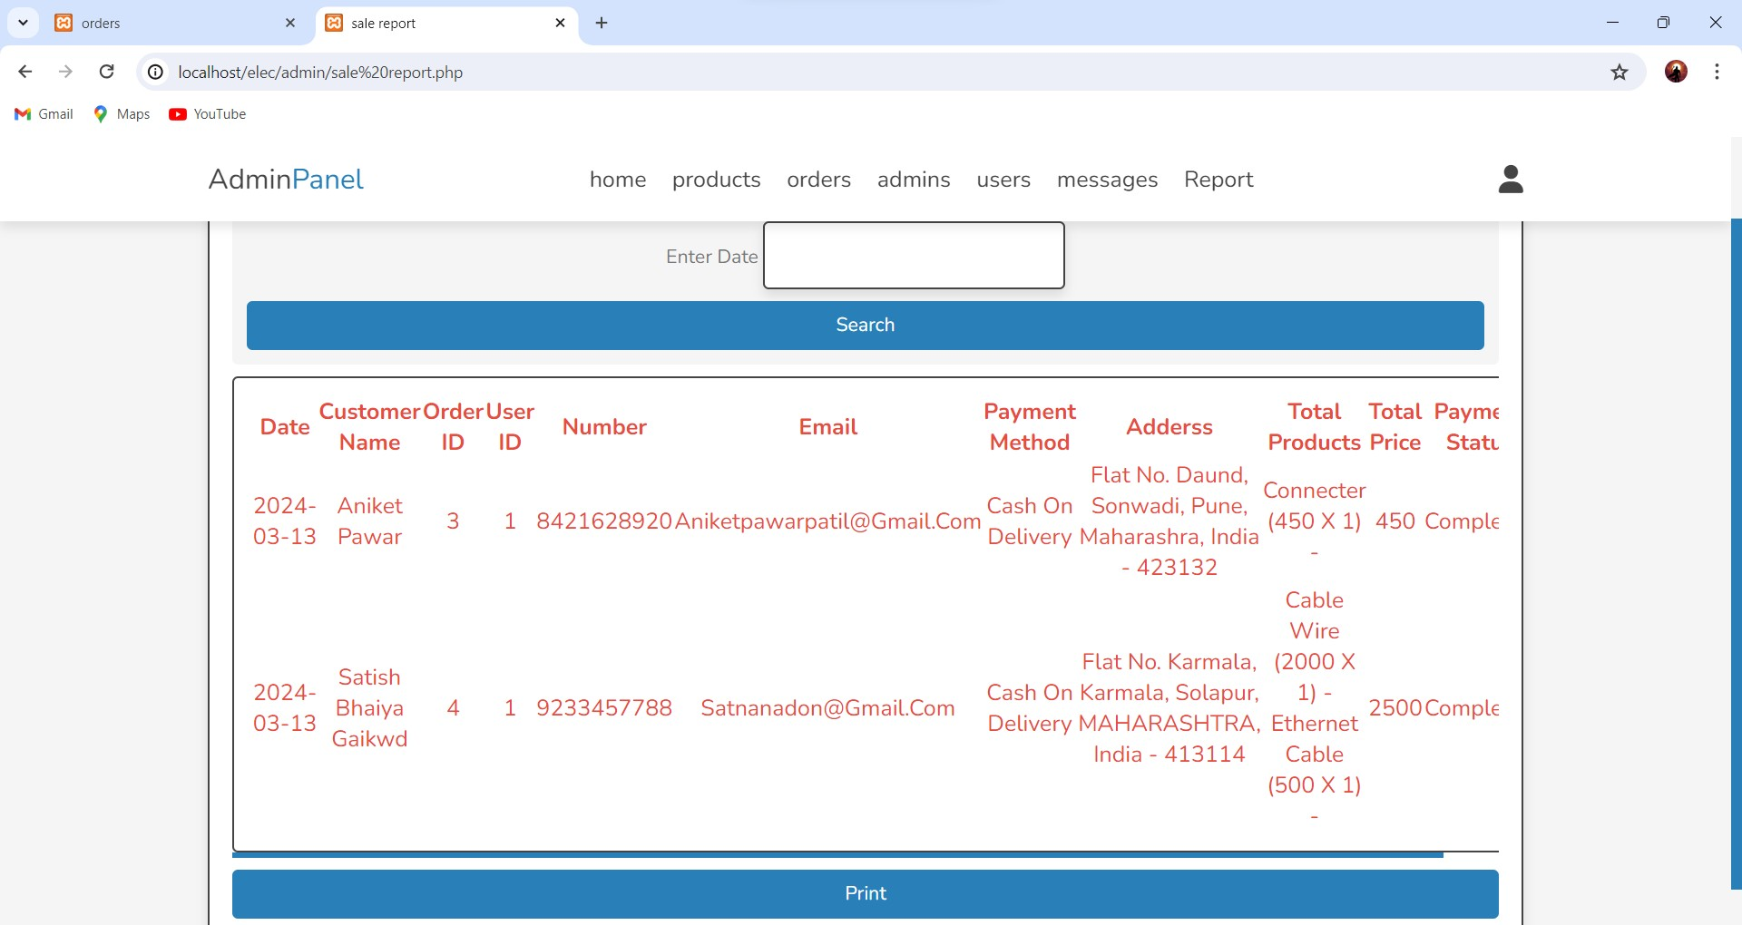



7 .

Conclusion

# 7 Conclusion

* + The project entitled Web Portal for Electrical shop was completed successfully.
  + This project helped us in gaining valuable information and practical knowledge on several topics like designing web pages using html and CSS, management of database using MySQL.



8.

Advantages

# Advantages : -

## Advantages

* + It saves paper
  + It saves time
  + It more secure
  + It stores details of customer, products, orders

## Limitations

1. The system provides limited facility to user.
2. In this project search bar not worked.



9

Future

Enhancement

# 9 Future Enhancement: -

* + **Online Payment:** In future will be adding online payment scheme for premium Test series.
  + **More Advance Test:** In future will be adding more fearure to make test series more advance and interactive .
  + **Google and Facebook Sign IN/P:** In future will be adding signup feature

such as with google,facebook,twitter



10

**Bibliography**

# 9 Bibliography: -

## Online References

1. HTML Tutorial (w3schools.com)
2. https [://www](http://www.geeksforgeeks.org/).ge[eksforgeeks.org](http://www.geeksforgeeks.org/)
3. [https://www.tutorialrepublic.com](https://www.tutorialrepublic.com/)

3. http[s://www.y](http://www.youtube.com/)outu[be.com](http://www.youtube.com/)